**ADDITIONAL SHEET - REGULAR HIRERS – Year 2021**

**DATES (Please circle required dates)** (*note that all dates required may not be available)*

**ORGANISATION ………………………………………………**

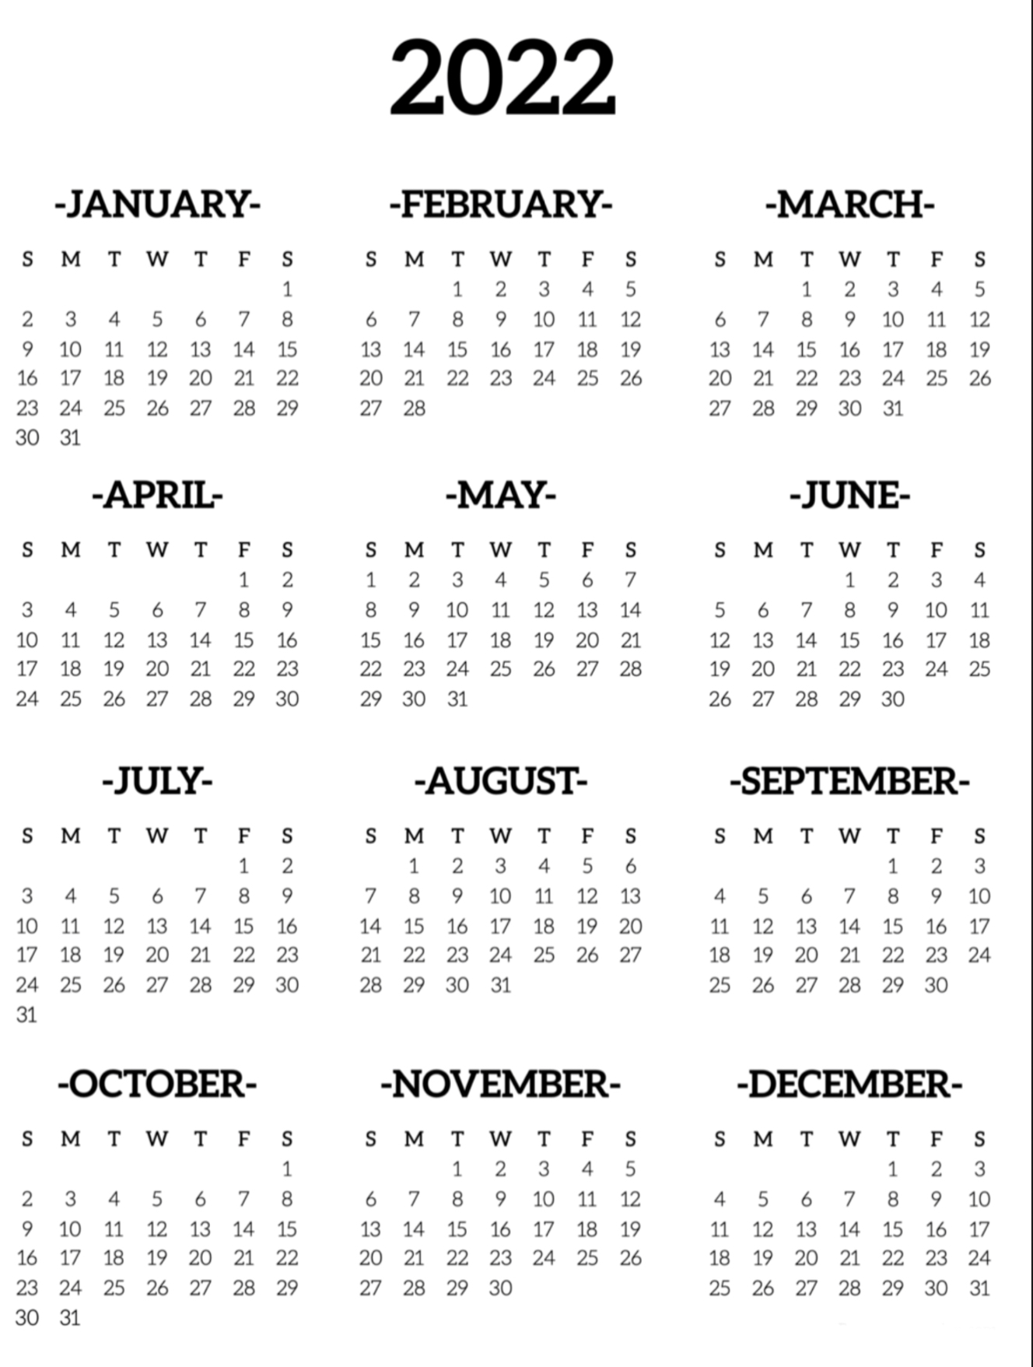

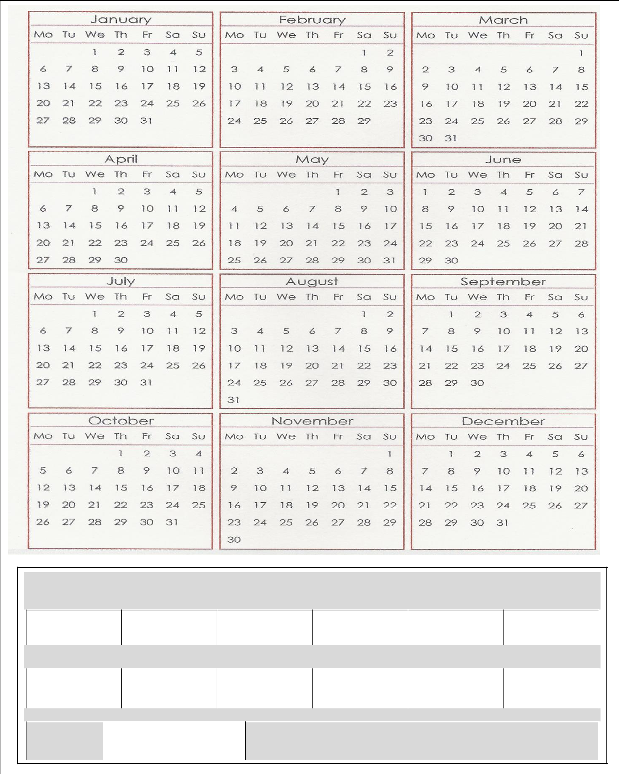

**OFFICE USEONLY**

**JANUARY** **FEBRUARY** **MARCH** **APRIL** **MAY** **JUNE**

**JULY** **AUGUST** **SEPTEMBER** **OCTOBER** **NOVEMBER** **DECEMBER**

**TOTAL**

**Payments MUST be made monthly in advance by the end of the first week of each month.**